LAB EXPERIMENTS AND EXECUTED OUPUTS

NAME | GEETIKA T
REG NO | 192511469
COURSE | ARTIFICIAL INTELLIGENCE
COURSE CODE | CSA1701

  - EXPERIMENT-11 To write a Python program to solve the Map Coloring problem using the Constraint Satisfaction Problem (CSP) technique.

AIM:
To write a Python program to solve the Map Coloring problem using the Constraint Satisfaction Problem (CSP) technique.
ALGORITHM:
- Start the program.
- Define the map regions and their neighboring regions.
- Define the available colors.
- Select an uncolored region.
- Assign a color that is not used by its neighboring regions.
- If the assignment satisfies all constraints, proceed to the next region.
- If no valid color is available, backtrack and try another color.
- Repeat until all regions are colored successfully.
- Display the regions and their assigned colors.
- Stop the program.
PROGRAM:
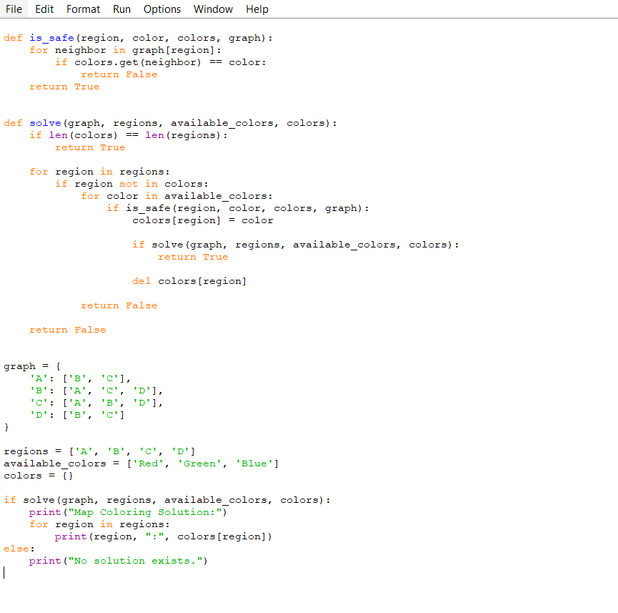

OUTPUT:
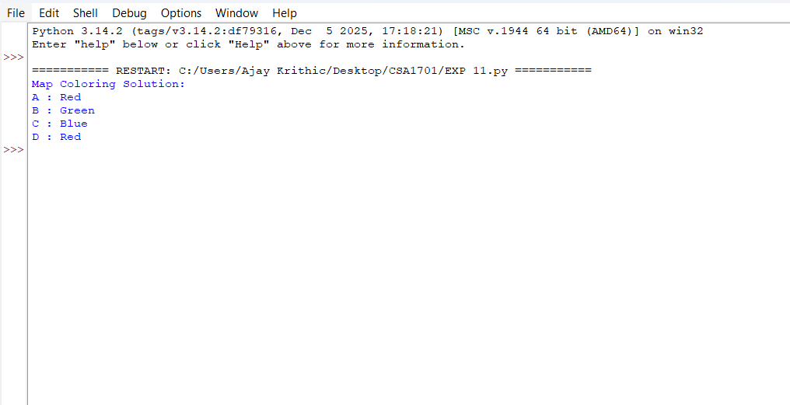
RESULT:
The Map Coloring problem was successfully solved using the Constraint Satisfaction Problem (CSP) technique with backtracking, ensuring that no two neighboring regions have the same color.

  - EXPERIMENT 12: Write the python program for Tic Tac Toe game

AIM:
To write a Python program to implement the Tic Tac Toe game between two players.
ALGORITHM:
- Start the program.
- Initialize a 3×3 board with empty spaces.
- Assign X to Player 1 and O to Player 2.
- Display the current game board.
- Ask the current player to enter a position from 1 to 9.
- Check whether the selected position is empty.
- If valid, place the player's symbol in that position.
- Check whether the player has won by completing a row, column, or diagonal.
- If a player wins, display the winner and stop.
- If the board is full, declare a draw.
- Otherwise, switch to the other player and repeat.
- Stop the program.
PROGRAM:
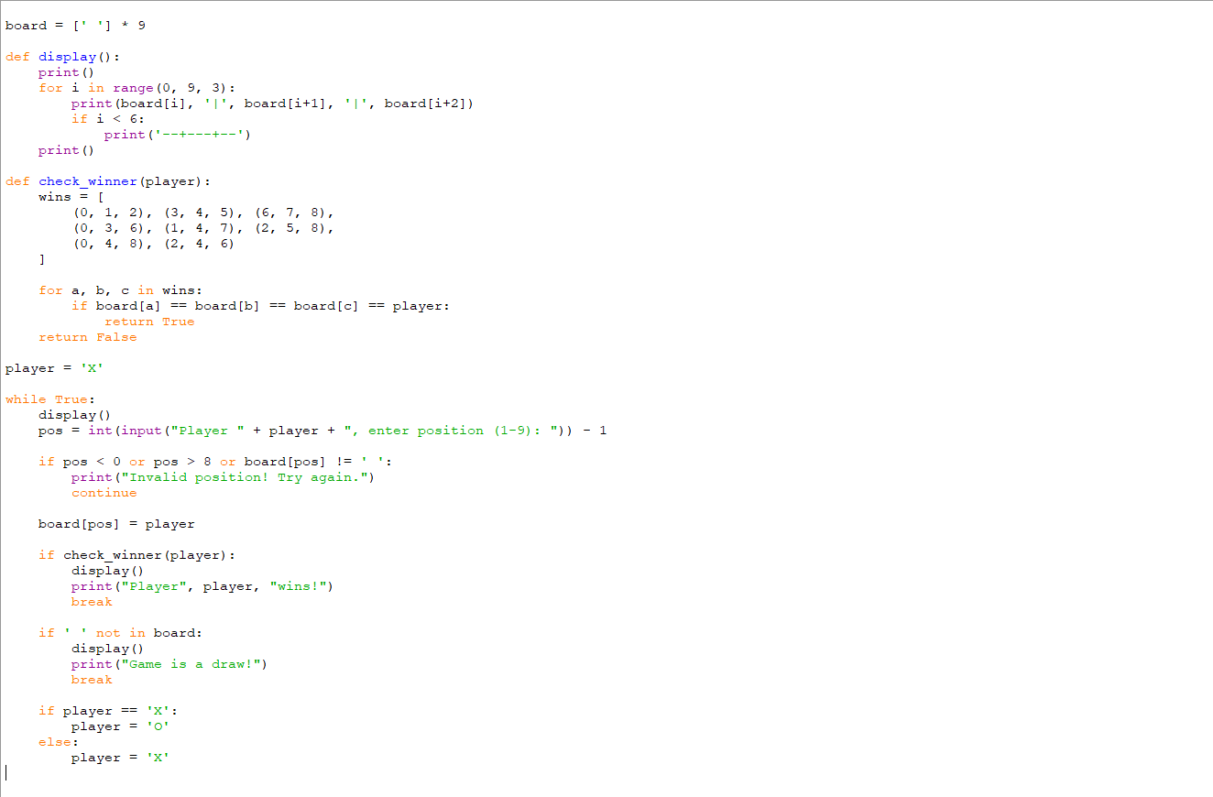
OUTPUT:
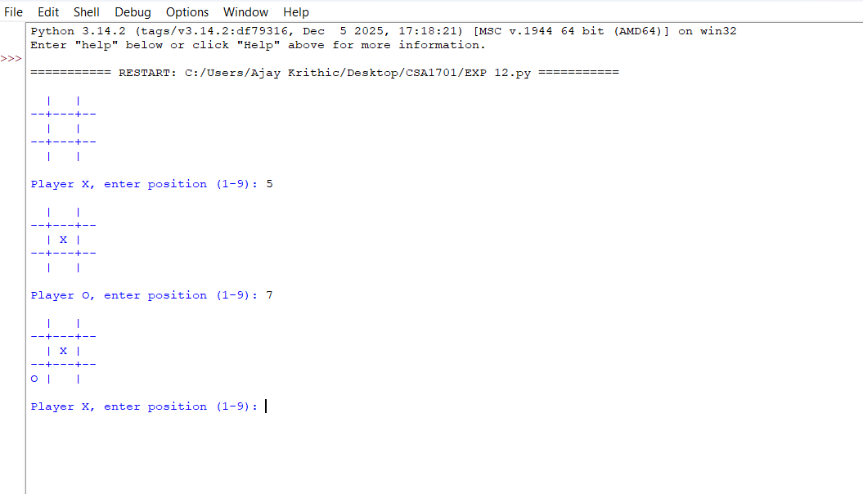
RESULT:
The Tic Tac Toe game was successfully implemented in Python for two players, including win detection, invalid move handling, and draw detection.

  - EXPERIMENT 13: Write the python program to implement Minimax algorithm for gaming

AIM:
To write a Python program to implement the Minimax algorithm for gaming to determine the optimal move for a player.
ALGORITHM:
- Start the program.
- Define the game tree with terminal node values.
- If the current node is a terminal node, return its value.
- If it is the maximizing player's turn, select the maximum value among its children.
- If it is the minimizing player's turn, select the minimum value among its children.
- Repeat the process recursively until the root node is evaluated.
- Display the optimal value and move.
- Stop the program.
PROGRAM:
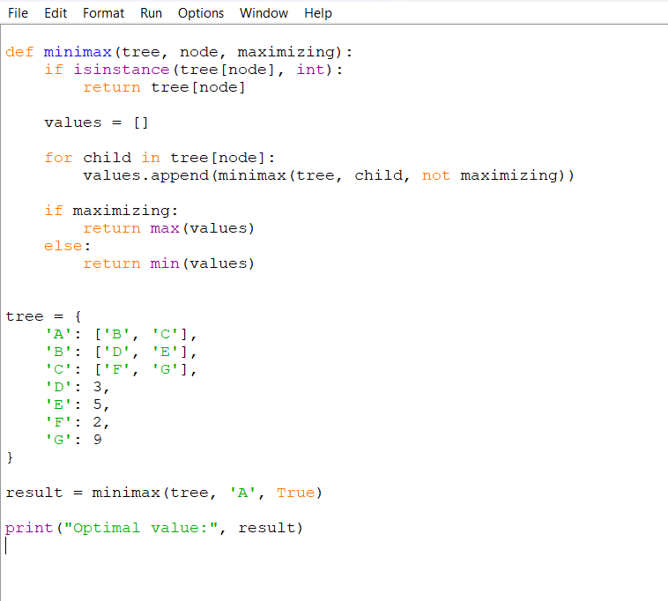
OUTPUT:

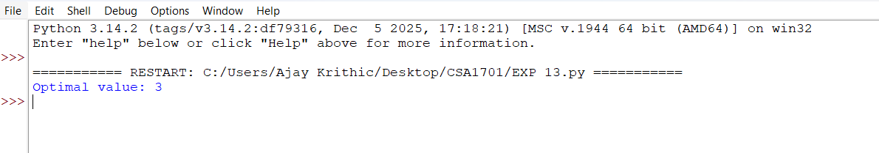
RESULT:
The Minimax algorithm was successfully implemented using recursion to evaluate the game tree and determine the optimal value for the maximizing player.

  - EXPERIMENT 14: Write the python program to implement Apha & Beta pruning algorithm for gaming

AIM:
To write a Python program to implement the Alpha-Beta Pruning algorithm for gaming to find the optimal move by eliminating unnecessary branches in a game tree.
ALGORITHMN:
- Start the program.
- Define the game tree with terminal node values.
- Initialize alpha to negative infinity and beta to positive infinity.
- If the current node is a terminal node, return its value.
- If it is the maximizing player's turn, find the maximum value and update alpha.
- If it is the minimizing player's turn, find the minimum value and update beta.
- If alpha is greater than or equal to beta, prune the remaining branches.
- Repeat recursively until the root node is evaluated.
- Display the optimal value.
- Stop the program.

PROGRAM:
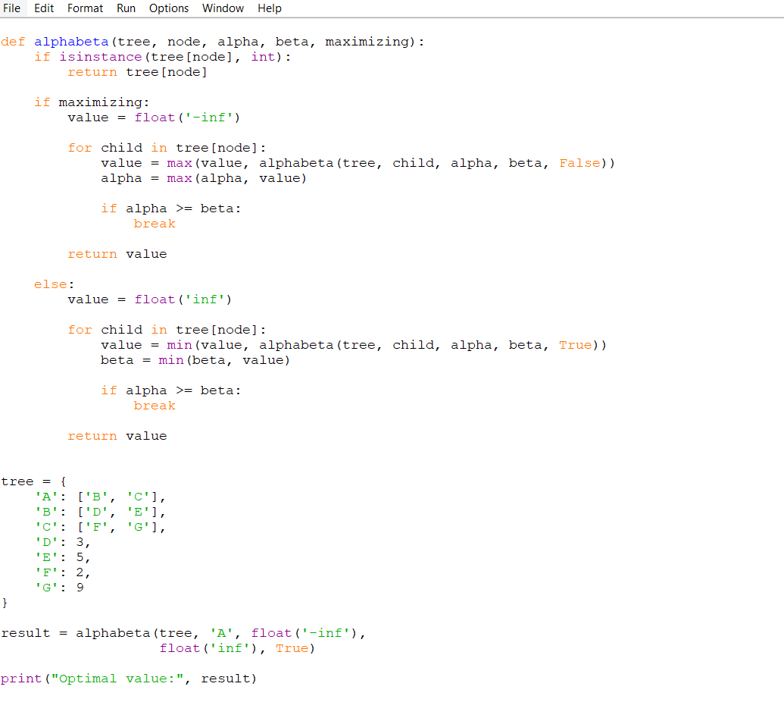
OUTPUT:

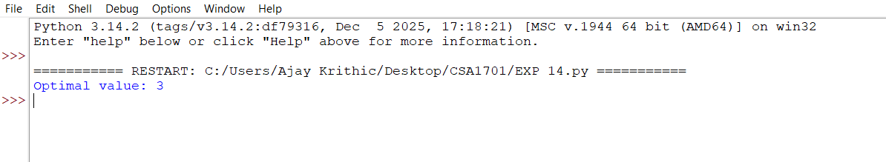
RESULT:
The Alpha-Beta Pruning algorithm was successfully implemented to determine the optimal value of a game tree while pruning unnecessary branches and reducing the number of nodes evaluated.

  - EXPERIMENT 15: Write the python program to implement Decision Tree
AIM:
To write a Python program to implement a Decision Tree classifier for predicting outcomes based on given input data.
ALGORITHM:
- Start the program.
- Import the required libraries.
- Create the dataset with input features and target values.
- Split the dataset into training and testing data.
- Create a Decision Tree classifier.
- Train the classifier using the training data.
- Predict the output for the test data.
- Display the predictions and accuracy.
- Stop the program.
PROGRAM:
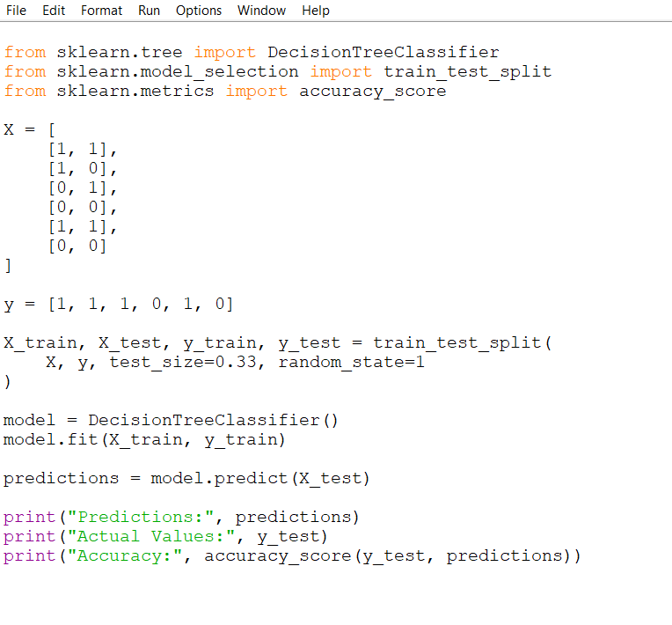
OUTPUT:
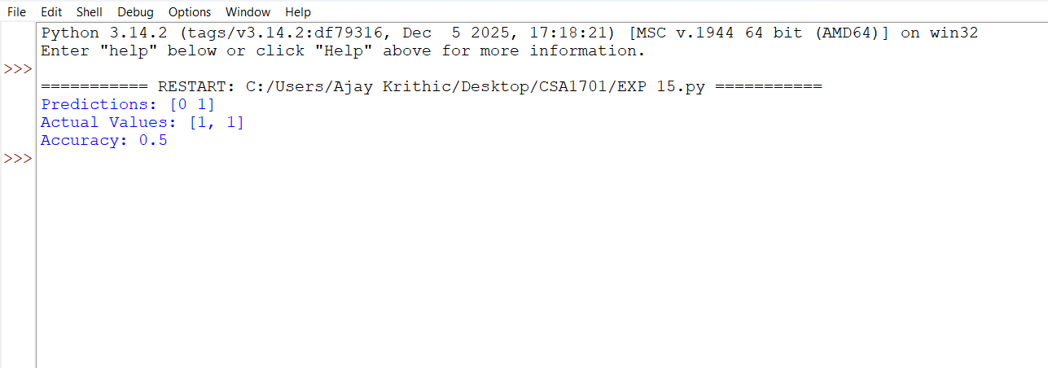
RESULT:
The Decision Tree classifier was successfully implemented and trained on the given dataset to predict output values and evaluate the model's accuracy.

